use ruthu

switched to db ruthu

> db.collection1.insertOne({"name":"ruthu","age":21,"status":"ready"})

{

"acknowledged" : true,

"insertedId" : ObjectId("6254f643ad197183fd365b12")

}

> db.collection1.find()

{ "_id" : ObjectId("6254f643ad197183fd365b12"), "name" : "ruthu", "age" : 21, "status" : "ready" }

> db.collection1.insertMany([{"name":"ram","age":21,"status":"ready"},{"name":"sam","age":28,"status":"pending"}])

{

"acknowledged" : true,

"insertedIds" : [

ObjectId("6254f750ad197183fd365b13"),

ObjectId("6254f750ad197183fd365b14")

]

}

> db.collection1.find()

{ "_id" : ObjectId("6254f643ad197183fd365b12"), "name" : "ruthu", "age" : 21, "status" : "ready" }

{ "_id" : ObjectId("6254f750ad197183fd365b13"), "name" : "ram", "age" : 21, "status" : "ready" }

{ "_id" : ObjectId("6254f750ad197183fd365b14"), "name" : "sam", "age" : 28, "status" : "pending" }

> db.collection1.update({age:21},{$set:{age:23}})

WriteResult({ "nMatched" : 1, "nUpserted" : 0, "nModified" : 1 })

> db.collection1.find()

{ "_id" : ObjectId("6254f643ad197183fd365b12"), "name" : "ruthu", "age" : 23, "status" : "ready" }

{ "_id" : ObjectId("6254f750ad197183fd365b13"), "name" : "ram", "age" : 21, "status" : "ready" }

{ "_id" : ObjectId("6254f750ad197183fd365b14"), "name" : "sam", "age" : 28, "status" : "pending" }

>

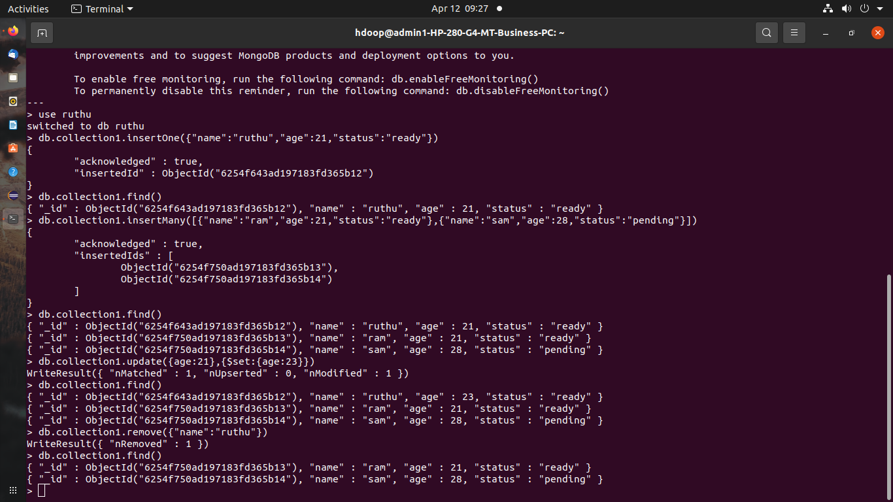

use ruthu

switched to db ruthu

> db.collection1.insertMany([{"name":"ruthu","age":20,"status":"ready"},{"name":"karen","age":28,"status":"pending"}])

{

"acknowledged" : true,

"insertedIds" : [

ObjectId("6254fd0065de64bd5ef42623"),

ObjectId("6254fd0065de64bd5ef42624")

]

}

> db.collection1.find()

{ "_id" : ObjectId("6254f750ad197183fd365b13"), "name" : "ram", "age" : 21, "status" : "ready" }

{ "_id" : ObjectId("6254f750ad197183fd365b14"), "name" : "sam", "age" : 28, "status" : "pending" }

{ "_id" : ObjectId("6254fd0065de64bd5ef42623"), "name" : "ruthu", "age" : 20, "status" : "ready" }

{ "_id" : ObjectId("6254fd0065de64bd5ef42624"), "name" : "karen", "age" : 28, "status" : "pending" }

> db.collection1.find({$or:[{"name":"ruthu"},{"age":28}]})

{ "_id" : ObjectId("6254f750ad197183fd365b14"), "name" : "sam", "age" : 28, "status" : "pending" }

{ "_id" : ObjectId("6254fd0065de64bd5ef42623"), "name" : "ruthu", "age" : 20, "status" : "ready" }

{ "_id" : ObjectId("6254fd0065de64bd5ef42624"), "name" : "karen", "age" : 28, "status" : "pending" }

>

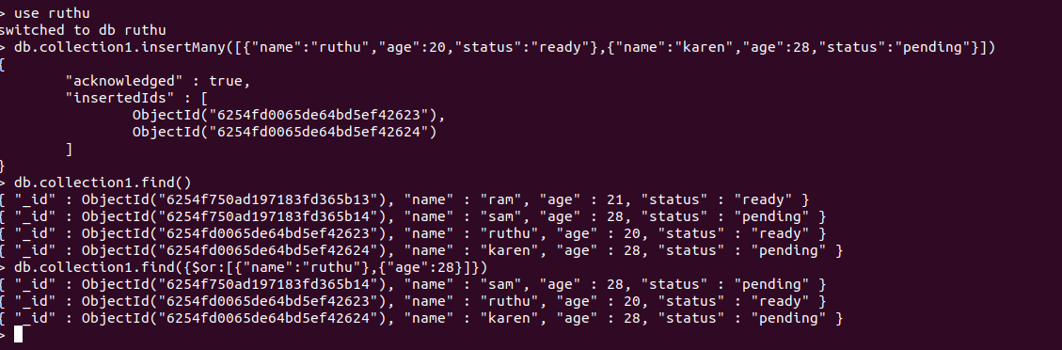

db.collection1.find({$and:[{"name":"ram"},{"age":21}]})

{ "_id" : ObjectId("6254f750ad197183fd365b13"), "name" : "ram", "age" : 21, "status" : "ready" }

